

DHOLE PATIL COLLEGE OF ENGINEERING WAGHOLI,PUNE- 412207

A

PROJECT REPORT ON

LIBRARY MANAGEMENT SYSTEM

# Submitted by

# Name Roll No PRN

# Prajwal Awandkar 01 72153940J

# Abhaysinh Deshmukh 06 72153968J

# Kunal Jumbad 14 72153998L

# Vishal Sale 40 72154104G

# Mayur Sonawane 45 72154128D

# Shivraj Mulik 25 72154043M

in partial fulfillment for the award of the degree

OF

BACHELOR OF ENGINEERING IN INFORMATION TECHNOLOGY AT

Savitribai Phule Pune University, Pune

Under The Guidance of Prof.

**DEPARTMENT OF INFORMATION TECHNOLOGY 2021-2022**



DHOLE PATIL COLLEGE OF ENGINEERING WAGHOLI,PUNE- 412207

DEPARTMENT OF INFORMATION TECHNOLOGY

# CERTIFICATE

This is to certify that,

|  |  |  |
| --- | --- | --- |
| **Prajwal Awandkar** | **72153940J** |  |
| **Abhaysinh Deshmukh** | **72153968J** |  |
| **Kunal Jumbad** | **72153998L** |  |
| **Vishal Sale** | **72154104G** |  |
| **Mayur Sonawane** | **72154128D** |  |
| **Shivraj Mulik** | **72154043M** |  |

have successfully completed project entitled, **"Library Management System"** in partial fulfillment for the award of the degree of **Bachelor of Engineering** in **Information Technology** of **Savitribai Phule Pune University** during academic year **2021-2022**. The project report has been approved as it satisfies the academic requirements in respect to Project work prescribed by the said degree.

Date:-

Place:-DPCOE

Prof. Nehali Shinde (Project Guide)

Prof. Rahul Ghode (Head of Department)

(External Examiner)

**Table of Contents:**

**Sr Title Page No.**

**No.**

1. **Introduction…………………… 1**
2. **Abstract………………………….. 2**
3. **Objective………………………… 3**
4. **Technical Words…………. 4**
5. **Problem Definition & Scope of the subject……………………………… 5**
6. **Project plan……………………. 6**
7. **SRS……………………………………. 7**
8. **Languages used in the project …. 15**
9. **Project plan……………………. 16**
10. **Project design……………….. 17**
11. **Result……………………………….. 19**
12. **Conclusion……………………… 21**
13. **Future Scope………………. 22**
14. **References…………………… 23**

**1**

**1. INTRODUCTION 1**

With the increase in the number of readers, better management of libraries system is required. The Library

management system focuses on improving the management of libraries in a city or town.

“What If you can check whether a book is available in the library through your phone?” or “what if instead of having different

library cards for different libraries you can just have one ?” or “you can reserve a book or issue a book from your phone sitting at your home!”. The Integrated Library Management system provides you the ease of issuing, renewing, or reserving a book from an library within your town through your phone.

The Integrated Library Management system is developed on the android platform which basically focuses on issuing, renewing and

reserving a book.

AIM OF THIS PROJECT WAS TO DELIVER A MINIMALISTIC, ROBUST, RELIABLE SYSTEM, THAT CAN BE EASILY DEBUGGED OR THAT IS SIMPLE ENOUGH TO BE USED, UNDERSTOOD & TROUBLESHOOTED BY NAÏVE USERS TOO.

CHERISHING THIS PHILOSOPHY TO THE HEART, OUR TEAM OF 6, HAS GIVEN PERHAPS MORE THAN 100% TO MANIFEST IT INTO REALITY.

**2. ABSTRACT 2**

The proposed Library Management System will take care of the current book detail at any point of

time.

The book issue, book return will update the current book details automatically so that user will

get the update current book details.

The interface is minimalistic & simple. Designed absolutely aligned with user comfort.

We’ve basically removed espionage of redundancies from this project.

*You-sire* need not to press enter for every single operation.

We’ve ensured that user has to press ‘Enter’ only while submitting the data. Meanwhile rest of the operations are solely operated via pressing appropriate numbers!

**3. OBJECTIVE 3**

The main objective of this document is to illustrate the requirements of the project

Library Management system. The document gives the detailed description of the both functional

and non-functional requirements proposed by the client. The purpose of this project is to provide

a friendly environment to maintain the details of books and library members. The main purpose

of this project is to maintain easy circulation system using computers and to provide different

reports.

**4. Technical Words 4**

Definition, Acronyms, Abbreviation:

JAVA -> platform independence

SQL -> Structured query Language

DFD -> Data Flow Diagram

CFD -> Context Flow Diagram

ER -> Entity Relationship

IDE -> Integrated Development Environment

SRS -> Software Requirement Specification

**5. Problem Definition & Scope of the 5 subject.**

1. Manually updating the library system into an android based application so that the user can know the

details of the books available and maximum limit on borrowing from their computer and also through their

phones.

1. The System provides information's like details of the books, insertion of new books, deletion of lost

books, limitation on issuing books, fine on keeping a book more than one month from the issued date.

1. Also user can provide feedback for adding some new books to the library.

Prime users:

A librarian, teacher, clerk or a record keeper.

This is primarily designed as a record keeping application to facilitate recording transactions of books, & its members.

**6. Project Plan 6**

**We a squad of 6 first arranged a meeting.**

**At first we discussed what problem we seek to solve. Books being the closest to us, we all embarked upon the decision to build morph the opportunity to build something that’s relatable, & not just a hollow subject with merely an illusion of explanatory depth. Secondly our momentum was fixated on the core essence, minimalism.**

**We do not seek to build a fancy software with fancy interface that would make a 8 year old go “Wow! But how do I use it?”.**

**But rather a minimalistic software system having simple interface with minimal options that can be relied upon blindly & would not need a manual.**

**And basic enough to be debugged, if any error occurs by any person equipped with basic knowledge of software.**

**Then divided the work amongst us.**

**7**

**7. LIBRARY MANAGEMENT SYSTEM**

**SRS**

MEMBERS:

Abhaysinh Deshmukh

Vishal Sale

Prajwal Awandkar

Mayur Sonawane

Kunal Jumbad

Shivraj Mulik

**8**

I - DESCRIPTION

The main objective of this document is to illustrate the requirements of the project

Library Management system. The document gives the detailed description of the both functional

and non-functional requirements proposed by the client. The purpose of this project is to provide

a friendly environment to maintain the details of books and library members. The main purpose

of this project is to maintain easy circulation system using computers and to provide different

reports.

II - Potential Users

Prime users:

A librarian, teacher, clerk or a record keeper.

This is primarily designed as a record keeping application to facilitate recording transactions of books, & its members.

III – Functionalities of the application **9**

1. **Book Details:**

This function contains all the actions regarding a book’s transaction.

They are;

1. Add Book Details:

To add a book this option is selected. Which promptly asks for details such as,

1. ID of the book that you wish to add.
2. Name of the book.
3. The author’s name
4. Price of the book.
5. No of copies available
6. Edit Book Details:

Editing a book detail requires further instructions such as,

1. ID of the book that you wish to edit
2. Updated cost of the book.
3. Delete A Book:
4. ID of the book that you wish to delete.
5. Search A Book:
6. ID of the book that you wish to search
7. **Member Details: 10**

This function contains all the actions regarding a member’s info.

They are;

1. Add Member Details:

To add a member this option is selected. Which promptly asks for details such as,

1. Member’s ID
2. Member’s Name
3. Member’s Address
4. Member’s Phone No
5. Edit Member Details:

To edit details of a member this option is selected.

The system asks for,

1. Member’s ID
2. Member’s new address
3. Delete a Member
4. Member’s ID
5. Search a Member
6. Member’s ID
7. **Transactions: 11**

This option has the transaction module. Basically, these functionalities to issue a book to a member & take back the book.

The options are such as;

1. Issue a Book:
   1. Member’s ID
   2. Book’s ID that the member seeks
   3. Date of issue of the book’s copy
   4. Count of copies the member wishes to take
2. Return a Book:
   1. Member’s ID
   2. Book’s ID that the member seeks to return
   3. Return date of the book’s copy
   4. Count of copies to be returned
3. **Report: 12**
4. Book Details:

Displays the whole table of content.

1. Member Details:

Displays the all of the members in a table format

1. Issue Details

Demonstrates the book’s issue date, member’s ID, Book’s ID, & the no of copies.

1. Return Details

Shows Return dates of the book, along with info same as earlier, member’s ID, Book’s ID & no of copies.

1. Best Reading Book

Visualization of a chart is shown. It shows data about the book’s popularity.

IV – System Requirements **13**

**Software Configuration: -**

This software package is developed using java as front end which is supported by sun micro

system. Microsoft SQL Server as the back end to store the database.

Operating System: Windows NT, windows 98, Windows XP

Language: Java Runtime Environment, Net beans 7.0.1 (front end)

Database: MS SQL Server (back end)

Hardware Configuration: -

Processor: Pentium(R)Dual-core CPU

Hard Disk: 40GB

RAM: 256 MB or more

V – Estimates **14**

a. Estimation of users:

1 to 4 at max, as stated earlier, this application is geared towards a librarian, teacher, clerk or a record keeper.

b. Estimation of load:

Depends upon the size of school.

Assuming an average sized school, of classes from std 1 to 10, holding 50 students per standard, roughly 5% of them using library each day of a fiscal year, around ~200 work days, excluding 165 off-days.

Annual Load = [(1*10)*50]*5/100*200

Annual Load = 5k Transactions/year

Daily Load = 25 Transactions/day

Or 3.5 Transactions/hr

1. **Language Used: 15**
2. **MySQL**
3. **PYTHON**
4. **. Project Plan: 16**

I – Flow Diagram

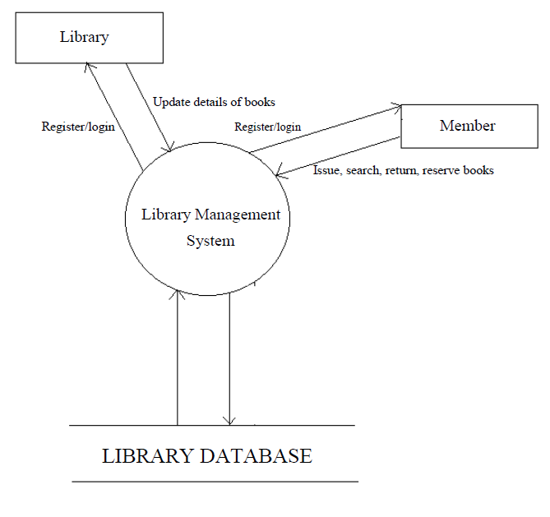

II – ER Diagram **17**

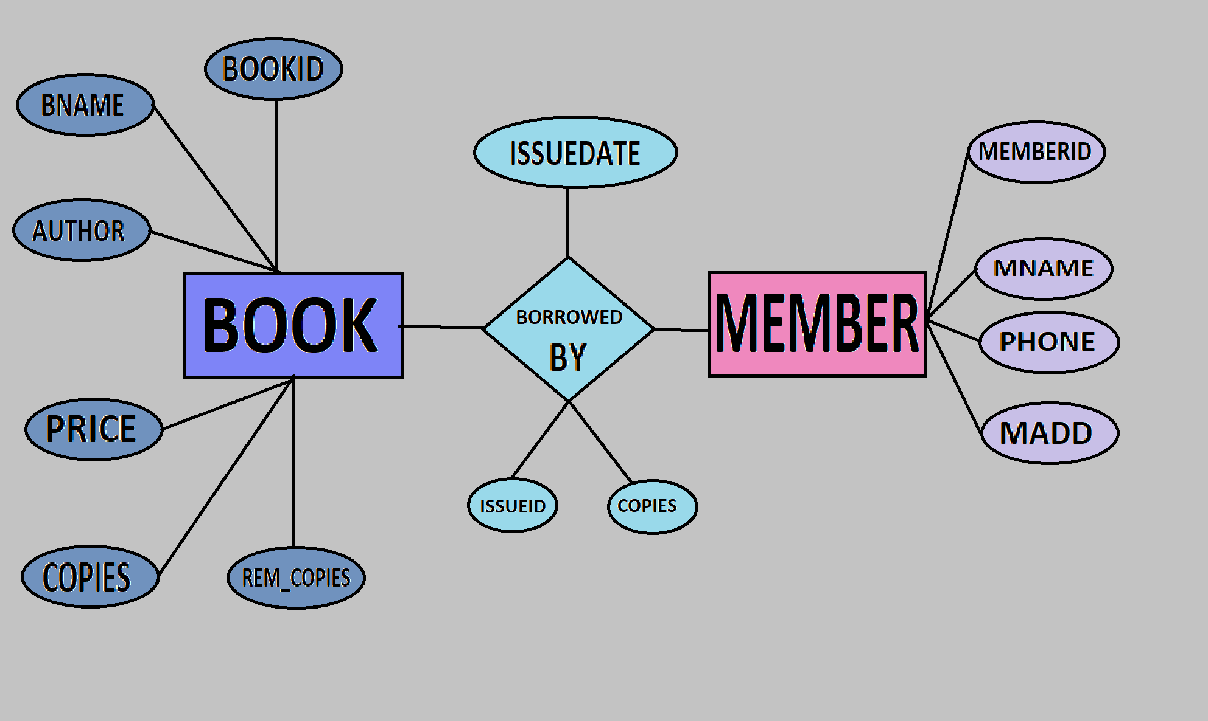

III – Schema Diagram

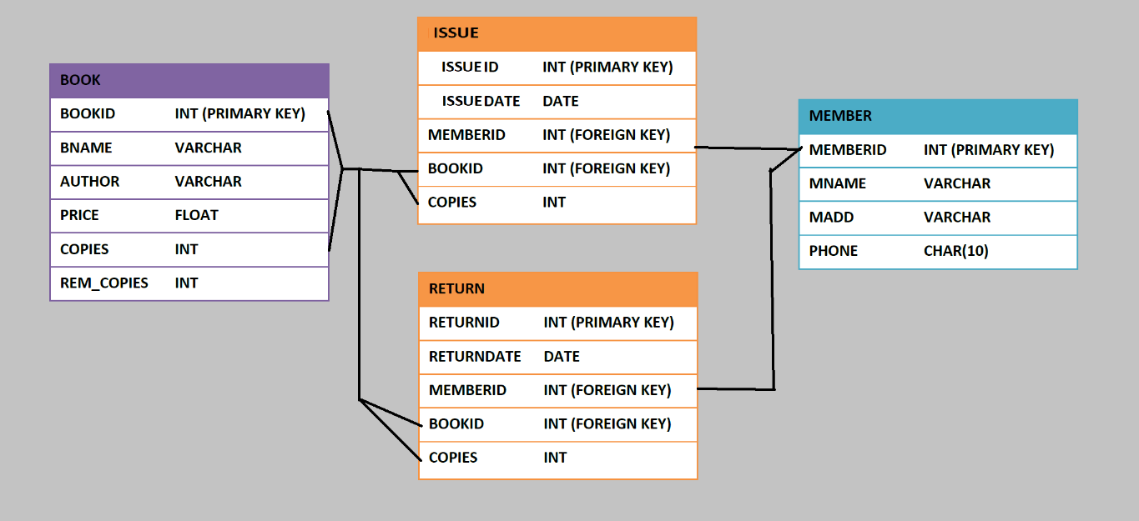

**10. Project Design: 18**

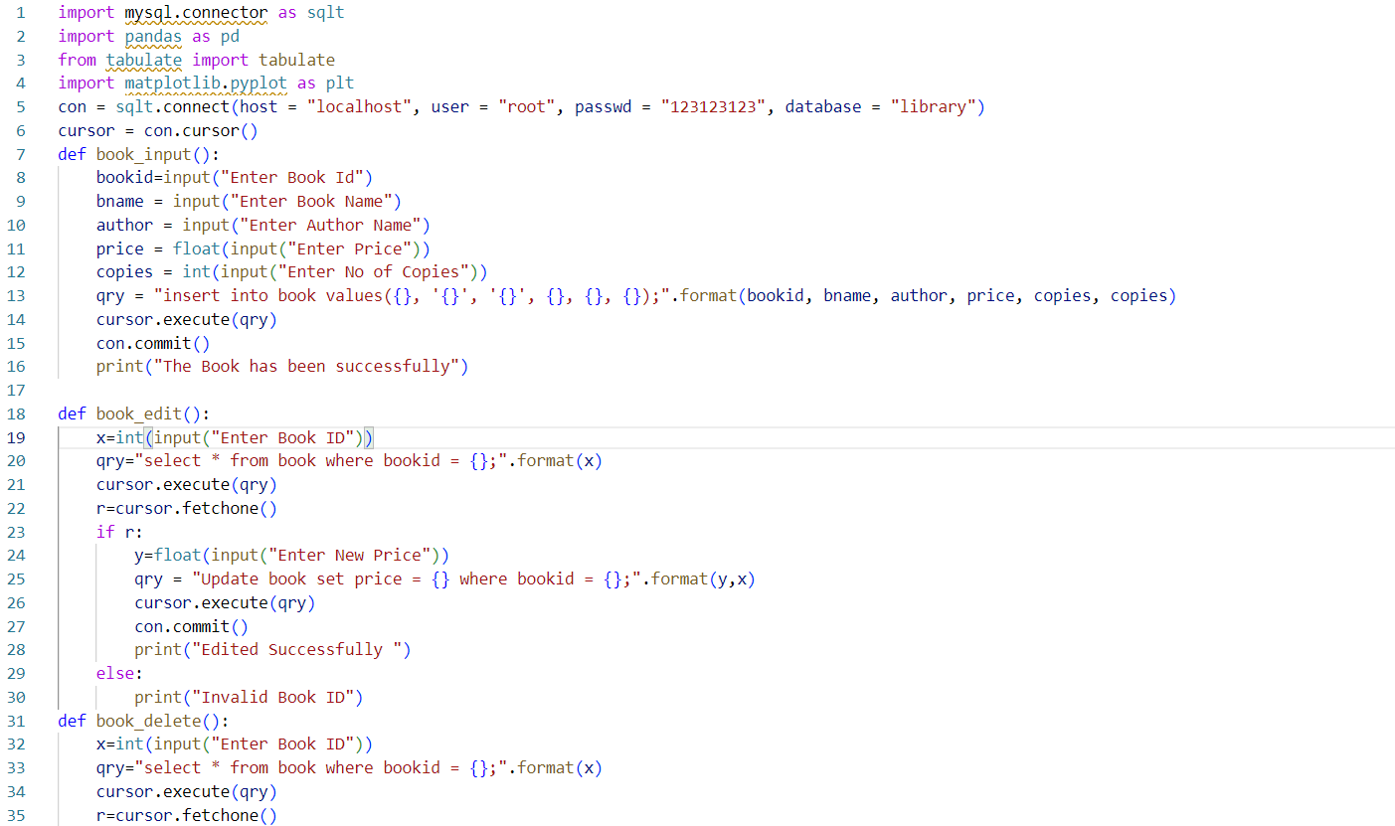

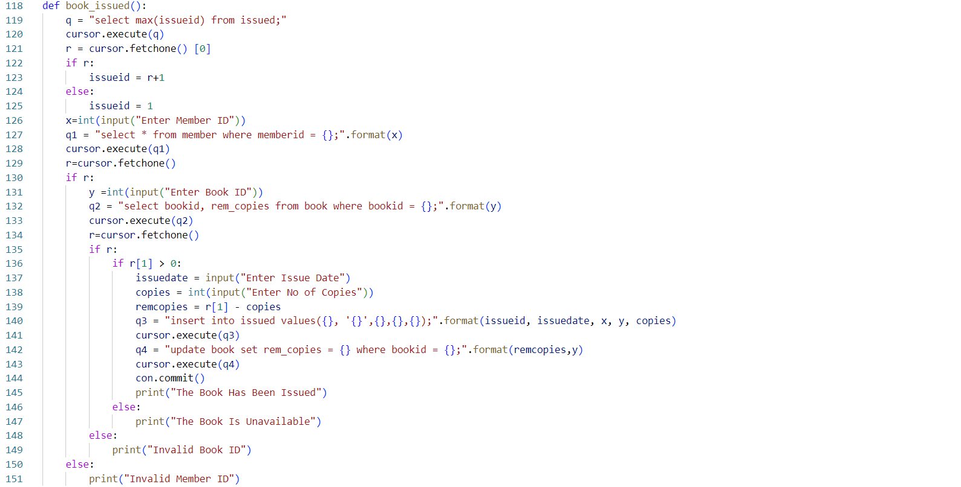

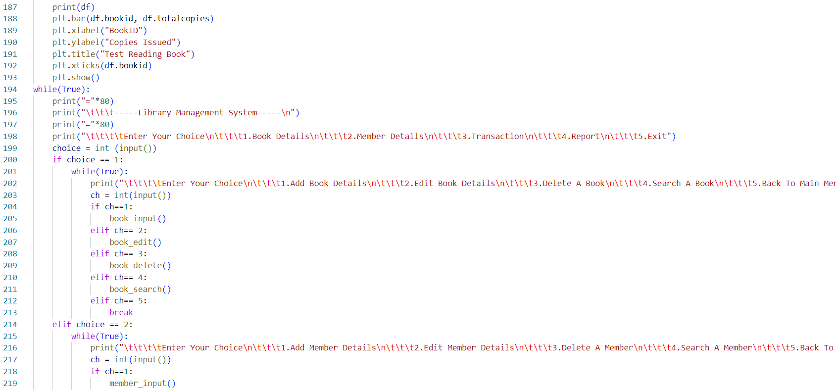

**11 . RESULT 19**

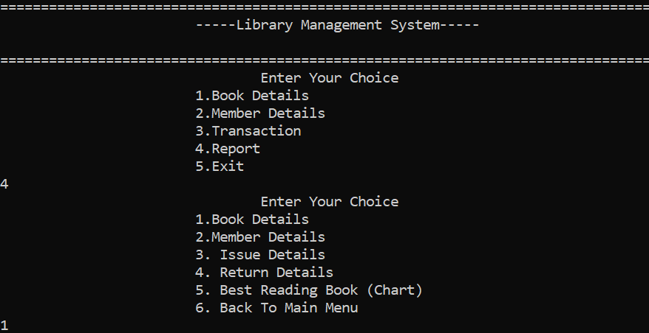 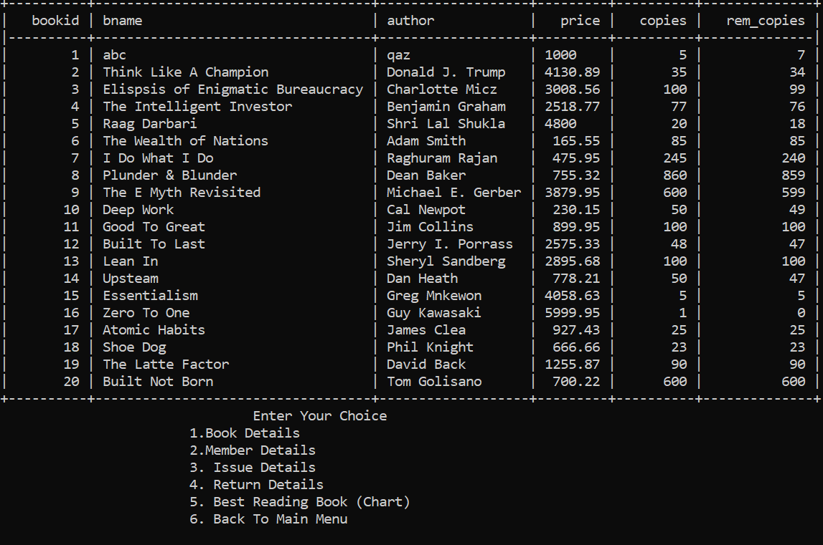

**20**

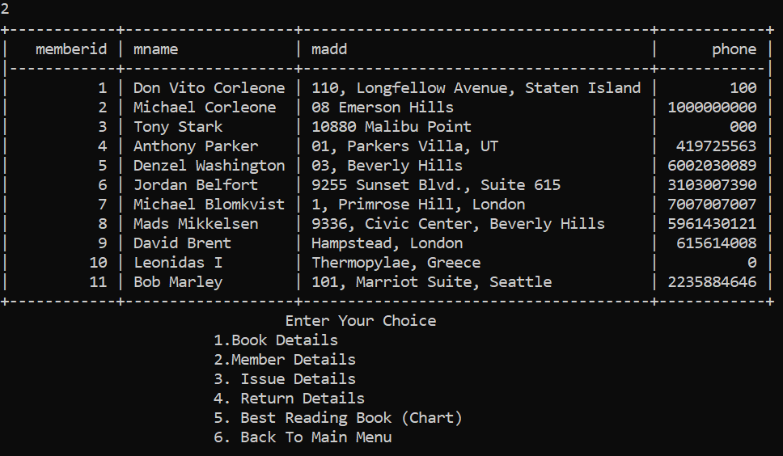

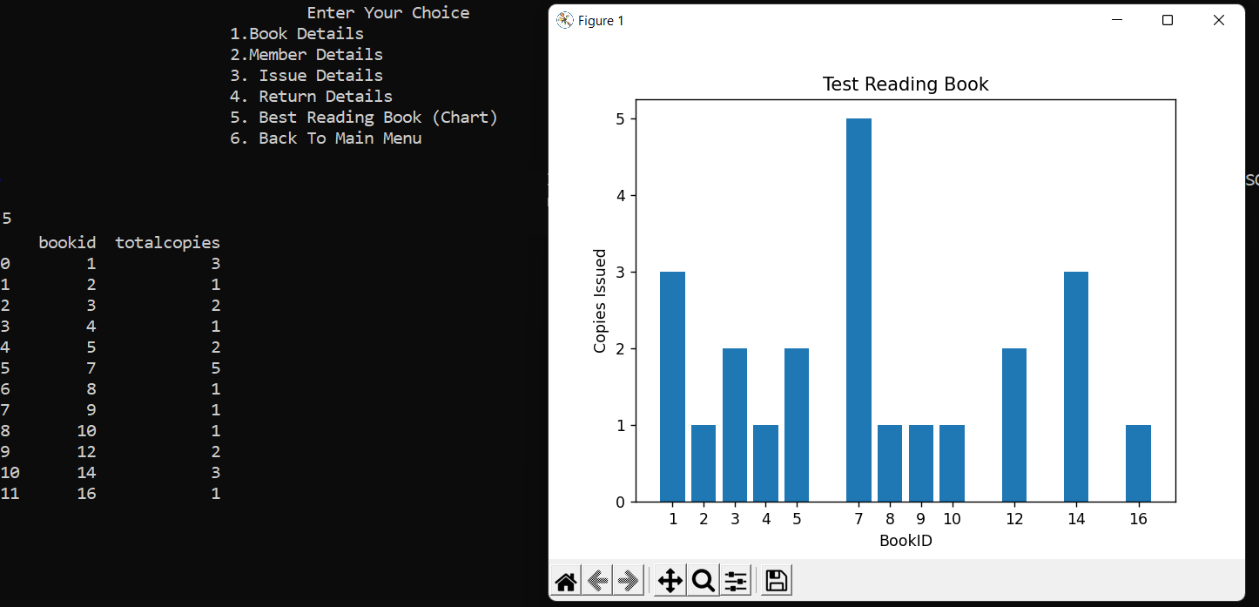 **12. CONCLUSION 21**

The is website provides a computerized version of library management system which will benefit the students as well as the staff of the library.

It makes entire process online where student can search books, staff can generate reports and do book transactions.

It also has a facility where student can see status of books issued as well request for book or give some suggestions. It has a facility of teacher’s login where teachers can add lectures notes and also give necessary suggestion to library and also add info about workshops or events happening in our college or nearby college in the online notice board.

**13. FUTURE SCOPE 22**

There is a future scope of this facility that many more features such as online lectures video tutorials can be added by teachers as well as online assignments submission facility , a feature Of group chat where students can discuss various issues of engineering can be added to this project thus making it more interactive more user friendly and project which fulfils each users need in the best way possible.

**14. FUTURE SCOPE 23**

http://www.w3schools.com/html/html_intro.asp

http://www.Udemy.com/css/css_background.asp

http://www.w3schools.com/js/js_datatypes.asp